16.32: The difference in path length is For destructive interference, 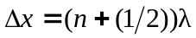,and for constructive interference, 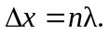The wavelength is (keeping an extra figure), and so to have 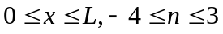 for destructive interference and 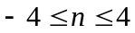for constructive interference. Note that neither speaker is at a point of constructive or destructive interference.
a) The points of destructive interference would be at 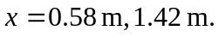
b) Constructive interference would be at the points 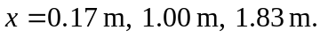
c) The positions are very sensitive to frequency, the amplitudes of the waves will not be the same (except possibly at the middle), and exact cancellation at any frequency is not likely. Also, treating the speakers as point sources is a poor approximation for these dimensions, and sound reaches these points after reflecting from the walls , ceiling, and floor.

